**Things that could be improved – Paul Ahn**

#1: case-specific catalog numbers have to be used (i.e. if the catalog number has a uppercase, it has to be written with the uppercase).

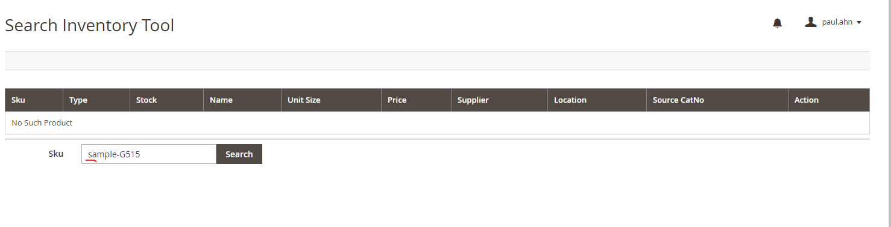

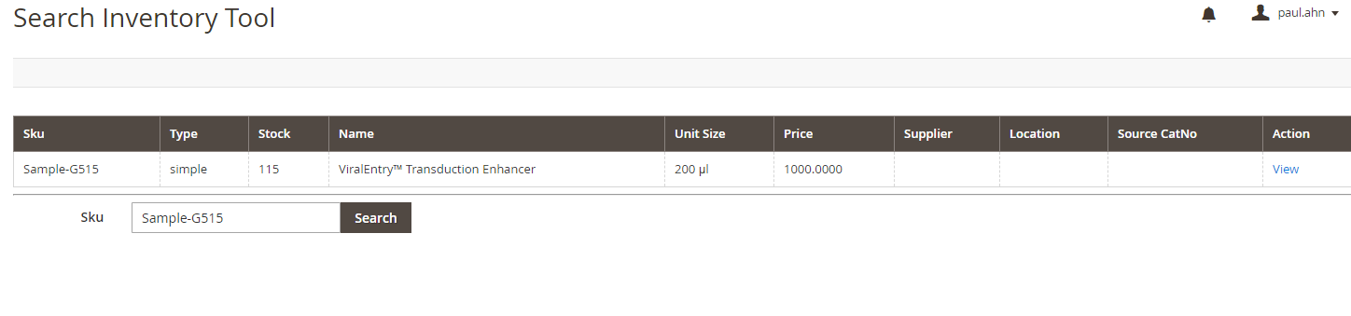

#2: additional selection is required for 12-digit catalog number. You are limited to searching based on the first 7 digits in the system and the following 5 digits have to be specified for the product. In another words, you cannot search for the product using the 12-digit catalog number directly. This issue is prevalent in inventory search, quote/order generation.

Ex) To search for 210001110195, you have to first find the product using 2100011 and select the rest once the product is found.

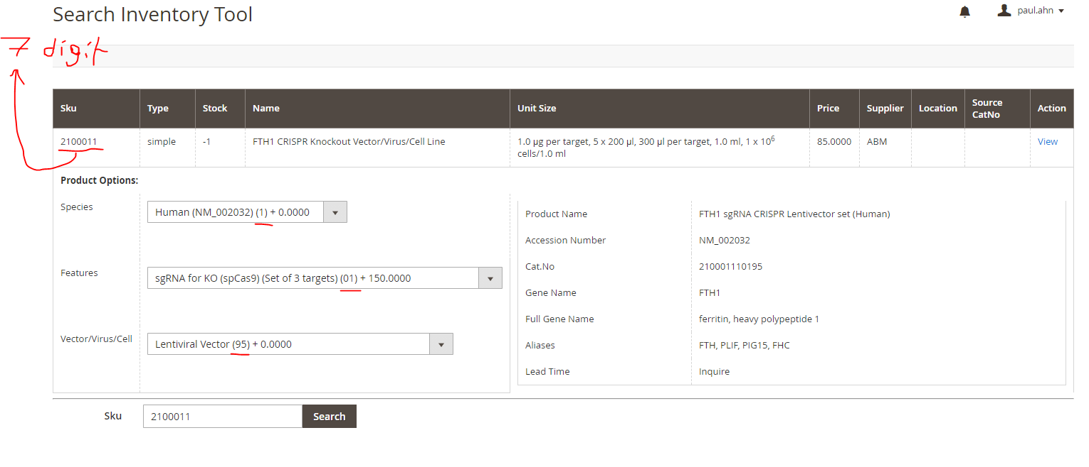

#3: When generating quote, HTML-related languages (e.g. <mark> to highlight, <p> to double space, etc) have to be used in the “Deliverables” “Lead Time” “Notes” section. This is contrary to the notes you can write for each product above; they can be written without HTML-related languages for proper function.

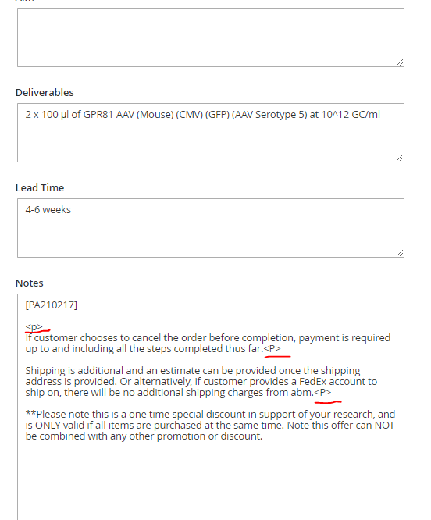

#4: When already-made quotes have to be revised, there are cases where the currency on the quote randomly change (e.g. from USD to Chinese Yuan). The exact amount (i.e. number) does not change.

#5: After quote is generated, I wish there is a way to change currency. Right now, the only way to change currency is BEFORE generating the quote.

#6: Custom Service Log and Orders are INDEPENDENT; you cannot access custom service log to check on the progress of the order directly from the order page. You have to manually goto Custom Service log and type in the order number (Unlike the old backend where the custom service log was available directly on the order page).

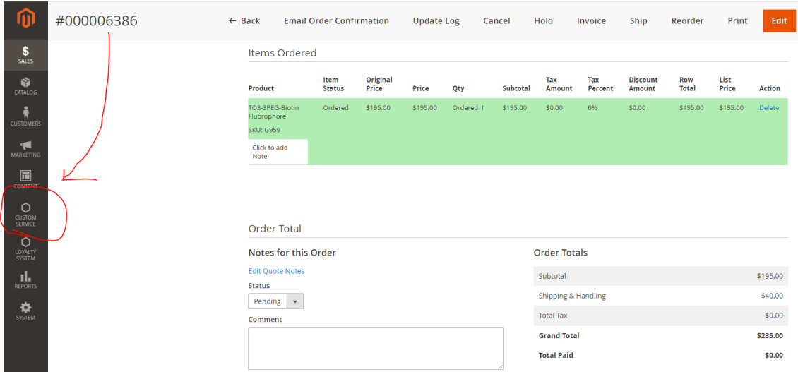

Adding New Customer

* Only really need “First Name” “Last Name” “Email”

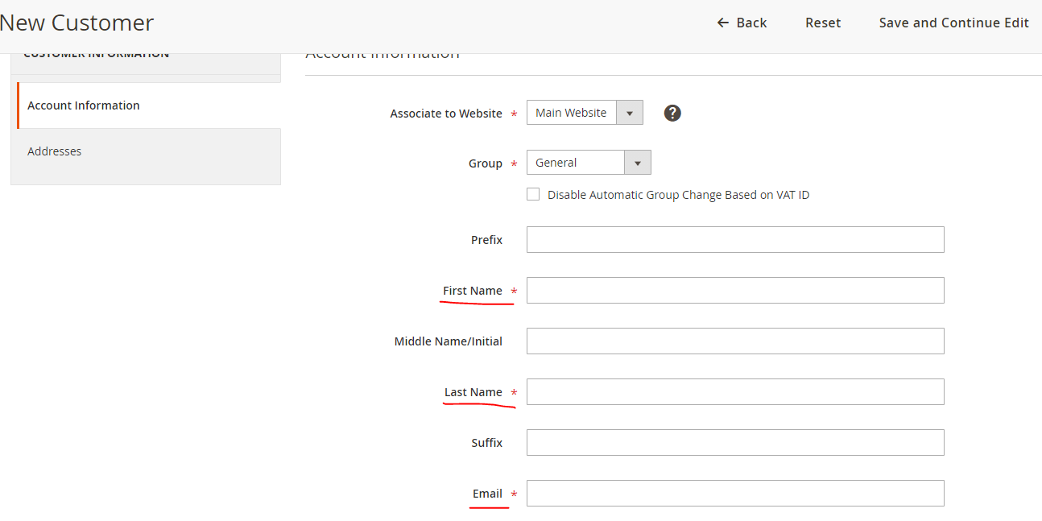

For the Address, only the ones that are indicated with red stars are required + Company

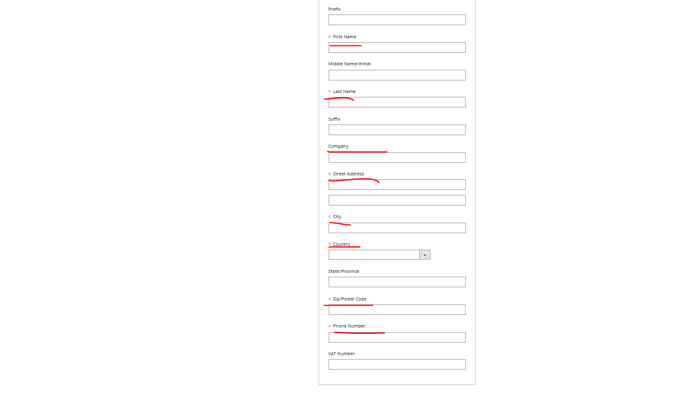

For Quote generation, it requires everything that is on the current backend (i.e. Items Quoted, Quote & Account Information)

For Orders, I wish the CSL updates (i.e. progress notes for the order) are updated automatically on the order page. In another word, I wish the Custom Service Log and Order Page are combined. Please refer to the image below:

